**STUDENT FACTS AND FIGURES**

**A Mini Project Report**

**BACHELOR OF TECHNOLOGY**

in

**Compute Science And Engineering**

by

**R. SREE VANI -20L31A05J9**

**U. RAGHAVENDRA VARA PRASAD -20L31A05O0**

**B. RAJA -20L31A05K1**

**V. SHARMILA PUJITA -20L31A05P0**

**P. PAVAN KUMAR -21L35A0519**

Under the esteemed guidance of

**Dr. G. Neelima**

Associate Professor

Department of Computer Science Engineering



**Department of CSE**

**VIGNAN’S INSTITUTE OF INFORMATION TECHNOLOGY VISAKHAPATNAM**

**(Autonomous)**

**(Approved by AICTE, New Delhi, Accredited by NBA,**

**Affiliated to Jawaharlal Nehru Technological University, Kakinada)**

**Besides VSEZ, Duvvada, Vadlapudi Post, Gajuwaka**

**Visakhapatnam -530049, A.P., India**

**2021-2022**

**VIGNAN’S INSTITUTE OF INFORMATION TECHNOLOGY**

**Department of CSE**



**CERTIFICATE**

This is to certify that this project report entitled “**Students Facts And Figures**” is a bonafide record of the work done by **R. Sree Vani 20L31A05J9, U. Raghavendra Vara Prasad 20L31A05O0, B. Raja 20L31A05K1, V. Sharmila Pujita 20L31A05P0, P. Pavan Kumar 21L35A0519**, in the Department of CSE**,** Vignan’s Institute of Information Technology, Visakhapatnam

|  |  |
| --- | --- |
| **Project Coordinator**  **Dr. G Neelima**  Associate Professor  Department of Computer Science Engineering,  Vignan’s Institute of Information Technology | **Head of the Department**  **Dr. B. Dinesh Reddy**  Head of Department  Department of CSE,  Vignan’s Institute of Information Technology |

**EXTERNAL EXAMINER**

**ACKNOWLEDGEMENT**

It gives us a great sense of pleasure to acknowledge the assistance and cooperation we have received from several persons while undertaking this B. Tech. Mini Project. We owe a special debt of gratitude to **Mrs. Dr. G. Neelima**, Associate Professor Department of Computer Science & Engineering, for his/her constant support and guidance throughout the course of our work. His/her sincerity, thoroughness and perseverance have been a constant source of inspiration for us.

We also take the opportunity to acknowledge the contribution of **Mr. B . DINESH REDDY** , Head of The Department of Computer Science & Engineering, for his/her full support and assistance during the development of the project.

We would like to express our special thanks of gratitude to **Mrs.ARUNDATHI**, Principal of VIIT, for his/her full support and assistance during the development of the project. We also do not like to miss the opportunity to acknowledge the contribution of all faculty members of the department for their kind assistance and cooperation during the development of our project.

Last but not the least, we acknowledge our friends for their contribution in the completion of the project.

R. Sree Vani -20L31A05J9

U. Raghavendra Vara Prasad -20L31A05O0

B. Raja -20L31A05K1

V. Sharmila Pujita -20L31A05P0

P. Pavan Kumar -21L31A519

Month :

Year :

**ABSTRACT**

This website is completely related to students. The students can gather information related to various subjects and syllabi, and get previous years’ question papers and examination timetables. The motive of the project is to provide all the related information to students in a single place. It consists of a login or registration page. Students of any year of Computer Science and Engineering Branch can access the website once they’ve created their accounts.

There will be no need to search for the study materials for their preparations because they can get a soft copy and video for the concepts they want to learn on one platform. That means, they can get topic wise content as well as videos for the subject or the unit they wish to read to.

**Keywords:**

providence, easy access, timetable, updates.

**CONTENTS**

**Title Page No**

CERTIFICATE ⅰ

ACKNOWLEDGEMENT ⅱ

ABSTRACT ⅲ

CONTENTS ⅳ

LISTS OF FIGURES ⅵ

NOMENCLATURE ⅶ

REFERENCES 33

**Chapter 1** INTRODUCTION

* 1. Web Development
     1. Evolution Of Web Development
     2. Why Is Web Development Important?
     3. Web Development Approaches
     4. Web Development Frameworks
     5. Popular Types Of Websites
  2. Web Development Life Cycle
     1. Steps In Web Development Life Cycle
  3. Frontend and Backend Languages
     1. Frontend Languages
     2. Backend Languages

**Chapter 2** LITERATURE REVIEW

2.1 Motivation Of The Project

2.2 Problem Analysis

2.3 Working Principles Of The Project

**Chapter 3**  SYSTEM ANALYSIS

3.1 Existing System

3.2 Proposed System

**Chapter 4** SYSTEM ARCHITECTURE

4.1 System Architecture

4.2 UML Diagram

**Chapter 5** REQUIREMENT AND SPECIFICATION

5.1 System Specifications

5.1.1 Hardware Specifications

5.1.2 Software Specifications

**Chapter 6** RESULT AND DISCUSSINS

6.1 Home Page

6.2 Registration Model

6.3 Login Model

6.4 Selection Model

6.5 Material/ Video/ Pdfs Page

6.6 Previous Year’s Question Paper Model

6.7 Updates

6.8 Announcements

**LIST OF FIGURES**

**Figure Page No.**

1.Web Development Life Cycle 12

2.Code for Registration Page 19

3.Code for Login Page 20

4. Code for selecting domains 21

5. System Architecture 23

6. UML Diagram 24

7.Home Page 26

8.Registration Page 27

9.Login Page 28

10.Selection Page Part 1 28

11.Selection Page Part 2 29

12.Material/ Video/ Pdfs Page 29

13.Previous Year Question Paper 30

14.Updates Page 31

15. Announcement Page 32

**NOMENCLATURE**

CMS - Content Management System

QA - Question-Answer

UI - User Interface

HTML - Hypertext Markup Language

CSS - Cascading Style Sheets

JS - Javascript

PHP - HypertextPreProcessor

**CHAPTER 1**

**INTRODUCTION**

* 1. **WEB DEVELOPMENT**

**Web development** is the work involved in developing a website for the Internet (World Wide Web) or an intranet (a private network). Web development can range from developing a simple single static page of plain text to complex web applications, electronic business, and social network services. A more comprehensive list of tasks to which Web development commonly refers, may include Web engineering, Web Design, Web content development, client liaison, client-side /server-side scripting, Web server and network security configuration, and e-commerce development.

Among Web professionals, "Web development" usually refers to the main non-design aspects of building Web sites: writing markup and coding. Web development may use content management systems (CMS) to make content changes easier and available with basic technical skills.

For larger organizations and businesses, Web development teams can consist of hundreds of people (Web developers) and follow standard methods like Agile methodologies while developing Web sites. Smaller organizations may only require a single permanent or contracting developer, or secondary assignment to related job positions such as a graphic designer or information systems technician. Web development may be a collaborative effort between departments rather than the domain of a designated department. There are three kinds of Web developer specialization: front-end developer, back-end developer, and full-stack developer. Front-end developers are responsible for behavior and visuals that run in the user browser, while back-end developers deal with the servers. Since the commercialization of the Web with Tim Berners Lee developing the World Wide Web at CERN, the industry has boomed and has become one of the most used technologies ever.

* + 1. **EVOLUTION OF WEB DEVELOPMENT**

Web Development was previously only known for the development of web pages and websites for both intranet and internet. However, nowadays it is more like creating web applications that surpass the complexity as well as the size of typical mobile and desktop applications. It can be said, web application development is the artsy method to develop complex business applications to both business (B2B) and customers (B2C).

Due to the modern complexity level, web development is done by a supple software team. This development was initiated as a way to develop apps around 15 years ago. The agile philosophy supports the regular delivery of software with the help of highly-motivated tech professionals. This agile software also supports frequent deliveries, changing environments, and whatnot. The agile team defends technical excellence, continuous improvements, great design, and reflection on how one can become more efficient.

Web technologies have emerged over the times to offer web designers and developers the skills to make a completely new peer of immersive and valuable experiences on the web to the users. The web that we see today is the outcome of regular ongoing efforts of an open community of web that assists in designing the latest technologies. Some of the techs that are being used today for web development are CSS3, WebGL, HTML 5, Java, React JS, Angular JS, PHP, etc. These technologies also ensure that the website or web app is supported in all web browsers.

During the start of web development evolution from the 90s to the current date, several things have changed and some of the features that were incorporated in its features:

* The sites were text-based
* Rise of Flash
* Sites were table-based with online page builders
* CSS Hits Web
* The Rise of JavaScript
* Semantic Web has come into view
* Web 2.0 was out
* Web Designs started embedding background images.
* Web Pages were divided into columns to aid numerous other customization of the sites.
* Different graphic elements began incorporating in the web applications
* Real-time visitor counters have become common on websites or web apps.
* Scrolling Marquee came into the picture
* GIF appearance started on the website
  + 1. **WHY IS WEB DEVELOPMENT IMPORTANT?**

A well-designed website may assist a business in reaching a broader and more engaged audience. A well-designed website is essential for reaching a larger audience and generating more leads or customers. Using a website, you can collect and read testimonials about your products and services much more quickly and easily.

Web development and design help to promote a company’s brand name. Essentially, if a firm’s website is accessible via the World Wide Web, the company is considered operating on a worldwide scale. This means that a little-known company may be looked for, and its items can be delivered to clients who are far away.

**What's required to create good website design?**

* Keep your design balanced.
* Compartmentalize your design by using grids.
* Pick two or three base colors at most for your design.
* Try to make the graphics go well together.
* Improve your website’s typography.
* Make elements stand out by adding white space around them.
* Have all elements connected.
  + 1. **WEB DEVELOPMENT APPROACHES**
* **Getting to know a client**

After the company gets a message from a lead, a sales manager and the lead discuss the needs (or the Scope of Work documentation if the lead already knows what (s)he wants). The sales manager briefs the lead about the desired outcome, the Definition of Done, timeline, budget, essential requirements, and possible bottlenecks. At this stage, the sales manager qualifies the lead and whether it fits the target audience of the company’s services: if a prospect needs a website and a PWA and a particular company builds only mobile apps, it’s definitely better to say farewells to each other.

### Discovery and project research

Discovery includes a deep investigation of the lead’s business requirements and the framing of a rough solution.

* What technology stack should be used?
* How an application will be scaled further and does this tech stack address further needs?
* Is there a match between our proposed solutions and the lead’s vision?
* Does this solution fit a budget?

### Wireframes and prototypes creation

A wireframe is literally a draft or a schema of a future web page. It includes all the blocks that should be placed on the page and gives an impression of a page’s grid. Having the wireframes in makes it possible to provide a more precise estimate and sweat the details of the functionality.

### UI design

Once the wireframes are complete, we can move on to the design of a user interface and apply brand colors and elements. A designer works on design assets until final approval. The lead developer controls the design process as the outcome should be realizable within the client’s budget.

### Back-end development

In web development which is our focus, initial installation and configuration go first. Then developers set up all necessary settings of modules.

After the pages are built and coded, and front-end developers applied designs, Drupal back-end developers make sure every website page is approved, and the client has gone through demo versions of every feature on the website.

### Front-end development

Depending on the project, the front-end and back-end development can go either in parallel or the back-end is followed by the front-end. A front-end developer implements all visual features and makes sure everything is pixel-perfect, and that a website is cross-browser compatible.

### Quality assurance

If you’re the client, never ever omit the testing stage. There are no minor issues when it comes to website performance. Believe us, your website’s visitors will notice every teeny-tiny bug.

After the integration test, we move to the functional and UI tests and end up with manual smoke testing.

### Launch

The bugs discovered at the QA stage are being fixed, the team finalizes everything and sets the final settings.

### Post-launch QA and maintenance

Besides maintenance and support, the development team usually teaches the client how to use a website, manage it and add content, etc.

* + 1. **WEB DEVELOPMENT FRAMEWORKS**
* **Angular (Frontend)**

Angular is one of the most prominent front-end frameworks leveraged by a huge number of web application development companies. Angular was first introduced in 2009 where it used JavaScript as its programming language. It was later transformed in 2016 and now uses Typescript instead of JavaScript. Angular is known to develop client-side dynamic web pages.

Angular is a large and all-inclusive framework that contains controllers, libraries, directives, and other components which makes it harder to learn as compared to other frameworks. Angular is based on MVC architecture (Model-View-Controller) and can be used to create high-performing single-page applications.

* **Vue.js (Frontend)**

Vue is a highly popular web framework used to build single-page apps and user interfaces for web apps. The framework is based on MVVM architecture (Model-View-View Model). It is lightweight and has numerous tools and features to create functional user interfaces. Vue is easy to use and learn and can be easily integrated with 3rd party tools and solutions.

* **React (Frontend)**

React is basically a JS library introduced by Facebook (now Meta). React works as a web framework and is mostly used to develop single-page front-end applications. Apart from it, it supports development for mobile applications which is usually not supported by the majority of other frameworks.

React effortlessly integrates with multiple other libraries for successfully conducting operations of routing, state management, and interaction with API.

* **jQuery (Frontend)**

jQuery is an open-source JavaScript library used for building app user interfaces. jQuery is known for its simplistic approach and cross-browser compatibility. The framework provides easy interaction between the elements of DOM and its syntax structure.

The framework is prominent due to its ability to create exceptional effects and animations in the developed apps. jQuery is small in size and has multiple plugins to easily add functionalities into its structure.

* **Ember (Frontend)**

Ember has earned the reputation of being the best Javascript framework many times. Ember offers various out-of-the-box features that can be used to develop highly functional applications. Ember is used by various tech giants such as Google, Microsoft, and Netflix.

Ember is based on the MVMM architecture and is simple to use. It eliminates the need for redundant tasks and adopts some of the best JS practices in its core design to develop web apps.

* **Django (Backend+Frontend)**

Django is a prominent Python framework that has an extremely high demand among developers and businesses. Django uses the concept of code reusability and follows the MVT (Model-View-Template) Architecture that enables it to develop applications at a faster pace. Django is one of the finest web frameworks that can be leveraged to create both the frontend and backend of the application.

The biggest corporations such as Instagram, Disqus, and NASA use Django to handle their backend operations. Some of the key features of Django are messaging, in-built validation, and authentication. This framework is suitable to design complex and large business projects.

* **Ruby (Backend)**

It is one of the oldest web development frameworks for building the backend of applications. It is based on the Ruby programming language and has developed over 800,000 websites until now. The framework supports usage of complex algorithms to design functional logic for complicated business problems.

It includes powerful libraries and tools and can be used to create cloud-based applications. Apps such as Airbnb, Hulu, GitHub, and Groupon are made using this framework.

* **Laravel (Backend)**

Laravel is a PHP-based framework that fundamentally works on the concept and paradigms of PHP scripting language. Laravel works on the MVC (Model-View-Controller) architecture.

It comes with API support and has numerous packages that make the framework adaptable and extensible. The framework is mostly used to design the backend of web apps. You can hire backend developers proficient in Laravel for small to mid-range web solutions.

* **Express.Js (Backend)**

Express is a Node.js API that is extremely powerful and can create highly productive web applications. It is mostly used by large enterprises due to its higher flexibility.

It has several in-built features and functionalities such as third-party integrations, routing, templating, server-side scripting, etc. that make it suitable to design functional apps. In addition, it has a minimalist feel and is easy to operate if you know the intricacies of the language.

* **Flask (Backend)**

Flask is a Python-based web framework that is known to build robust, lightweight, and high-performing applications. It is a microframework and includes all the necessary libraries and functions to create applications from scratch to ultimate.

The key features of Flask include a built-in web server and debugger, RESTful request dispatching, unit testing support, WSGI compliance, and Unicode support.

* + 1. **POPULAR TYPES OF WEB SITES:**

## **Business**

### Purpose

To inform prospective clients and consumers about your business and entice them to work with you

### Features

* explanation of services
* company bio (typically the About page)
* company basics (address, phone number, email, etc.)
* mission statement
* address pain points and present value statement
* call-to-action for working together

## **Ecommerce**

### Purpose

To sell items online with a conventional retail method.

### Features

* production gallery with high-quality images
* product pages
* secure checkout/transaction capabilities (with SSL certificate)
* account personalization options (wishlists, saved orders, profile pages, etc.)

## **Blogs/news**

### Purpose

To educate or inform the visitor about current events or specialized knowledge (like this article about web design on our 99designs blog).

### Features

* article catalogs
* dedicated pages for each article
* categorization or tags for convenient browsing
* payment gateways and account capabilities, if applicable

## **Portfolio**

### Purpose

To display samples of work for certain professionals and attract more clientele

### Features

* gallery of high-quality images and work samples
* information about the professional or agency
* explanation of services
* call-to-action for working together

## **Service provider (streaming, online tools, etc.)**

### Purpose

To offer a complete online service, such as streaming or online tools like search engines, spell-checkers, photo editors, or translators.

### Features

* easy-access to the tool
* payment options for subscriptions
* account personalization (favorites, recommendations, taste tracking, etc.)
* **Landing Page**

**Purpose**

To drive customers to a single, specific action, usually as part of a greater marketing campaign

### Features

* a single, prominent call-to-action
* brief description of services/sales pitch

## **Wiki/database**

### Purpose

To provide a wide berth of information and act as a reference guide.

### Features

* large number of pages
* easy and effective search functions
* account capabilities for users to edit and create their own pages (optional)

## **Forum**

### Purpose

* To allow users to discuss amongst themselves and share information and links with each other, usually dedicated to specific topics.

### Features

* organized discussion boards by topic
* user-content generation (users can upload their own content independently)
* moderators
* account personalization (favorites, notifications for responses, profile bios, etc.)
* **Event**

**Purpose**

To plan events and consolidate information for attendees

**Features**

* signup functionality
* current guest lists
* event details and schedule
* helpful information like driving direction or what to bring
  1. **WEB DEVELOPMENT LIFE CYCLE**

The software and web development life cycle adheres to a specific standard that has to be followed to move in the right direction. There are frameworks, methodologies, modeling tools, and languages involved.

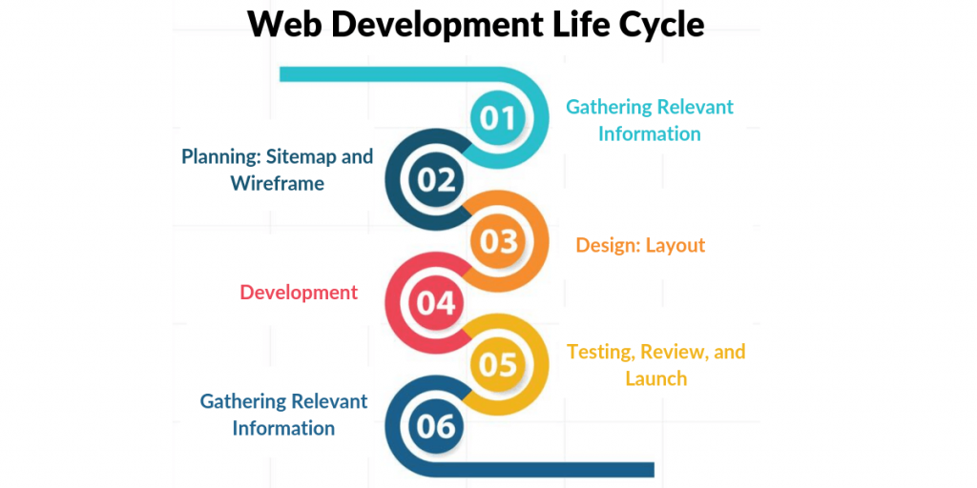

Figure1:Web Development Life Cycle

## **1.2.1 STEPS IN WEB DEVELOPMENT LIFE CYCLE**

## **Gathering Relevant Information**

The first stage is the most important as it involves understanding the client’s requirements. Identify their needs and help them in providing the perfect solution. Have a clear idea about the target audience. What the business goals are and how the website will be utilized to accomplish those objectives.

## **Planning – Sitemap and Wireframe**

With all the information that has been gathered from stage one, the design and implementation strategies are planned according to the type of website and target audience. A site map is created in this phase.

For building a full-fledged website having impeccable features and functionalities, it is important to plan wisely. There has to be a detailed list of all the areas of the website and the sub-topics. This is a guide that describes what content will be there on the site, and there is an easy-to-understand navigational system.

Think of the best user interface that is created for easy navigation. The wireframes give an outline of the pages of the website.

Take the help of tools for creating the wireframe. All the planning processes should have the involvement of the client. So, the client has an idea about the blueprint of the project.

## **Design & Layout**

Next is to determine the look and feel of the website. In the design phase, it is essential to embed elements like the logo of the company and the colors that help to enhance to identification of the company on the website.

The designer gives life to the graphics, typography, colors, animations, buttons, drop-down and pop-up menus, and more as per the project requirement.

It is the responsibility of the web designer to create one or more than one prototype for the website. This is basically a jpeg image of the final design. Designers give companies access to the workflow so that they can view the progress of the development.

Meeting the demand of the audience with the help of web design is also crucial. If the design is mundane, the website will not be able to capture the user’s attention, and this will increase the bounce rate. The elements should reflect the brand image as well as the business vision.

## **Development**

The development is a stage where the website is built while maintaining the essence of the website’s purpose. All the graphic elements are taken into consideration and are used to generate a functional website.

The process begins with first developing the home page followed by the interior pages. The main focus is given to the navigational structure of the site.

Content Management System, interactive contact us forms, and shopping carts are made functional in this development step. The web design & development company suggests changes that are done after consideration.

## **Testing, Review, and Launch**

After the completion of web development, it is tested. The functionality is tested along with the device compatibility.

The web designer should be well-versed with the current trends and standards so that the design and development are done accordingly. The technologies used are HTML and CSS. The tester validates the codes written for the website.

When the designer is given the final approval, the website is ready for delivery. The quality assurance team tests for functionality, compatibility, and performance to ensure that the website is ready for the launch.

Other testing includes integration testing, stress testing, scalability, load testing, resolution testing, and cross-browser compatibility. Once the green flag is shown, it is deployed to the server using FTP.

## **Maintenance and Updation**

The web development stages don’t end after deployment. There are many post-deployment tasks that take place. Some elements are changed as per the user’s feedback, support, and maintenance.

One good way to grab potential visitors and repeat their visits is to keep updating the content and adding new products on a regular basis. The website drives by CMS allows the customer to edit the content.

* 1. **FRONTEND AND BACKEND LANGUAGES**

Frontend and Backend are the two most popular terms used in web development. These terms are very crucial for web development but are quite different from each other. Each side needs to communicate and operate effectively with the other as a single unit to improve the website’s functionality.

## **1.3.1 FRONTEND LANGUAGES**

## **HyperText Markup Language (HTML)**

The most extensively used Frontend Language is HTML, which is a markup language. Hypertext Markup Language is the abbreviation for HyperText Markup Language. It's a programming language that is used to make websites and web apps.

* The term "text wrapped within a text" is used to describe HyperText. It is similar to a hyperlink which has an underlying text that, when clicked, takes you to a different webpage.
* A programming language is not always the same as a markup language. It's instead used to add formatting and layout to a plain text document. As a result, more interactive and dynamic text material is produced.
* A web page is a document that is usually written in HTML and displayed via a web browser. A URL identifies each web page, which might be static or dynamic depending on the needs. We can generate static web pages if we solely use HTML for development.

## **Cascading Style Sheets (CSS)**

Although CSS is a style sheet, it is also considered as the top Frontend Language. CSS, or Cascading Style Sheets, is a design language that simplifies making web pages presentable. Selectors are used to pick elements and apply styles to them. CSS is used to turn a document into a format that audiences can understand. This is especially important for browsers like Chrome, Firefox, and Edge, designed to deliver documents to screens, printers, and projectors visually.  CSS is widely used because it saves time, has easy maintenance, offers selectors, text effects, and layouts.

## **JavaScript**

JavaScript is a robust client-side programming language that is open-source. Its primary purpose is to enhance a user's interaction with a web page. In other words, you can utilize this programming language to improve the vibrancy and engagement of your website. JavaScript is also widely used in the development of games and mobile apps. Excellent speed, cross-browser interoperability, and straightforward semantics are just a few of JavaScript's essential qualities, providing a seamless developer experience.

**1.3.2 BACKEND LANGUAGES**

* **C#**

C# is a high-level language that can operate on various types of computers easily. Programmers use this powerful language with frameworks like .NET to design the internal structure of webpages and connect client interactions with server interactions for a fully functioning program. The versatility and stability of C# and its related frameworks make it a reliable choice for web and software development.

* **GOLANG**

Golang, sometimes shortened to Go, is a static language, which means it catches errors before running the program, which makes it easy to find specific bugs in your code before testing your program. With its simple and practical syntax, you can efficiently write code for the back end of a piece of technology and scale it up or down when needed.

* **JAVA**

Java is a popular language for developers who want to create large, dependable web applications that require high-security measures to keep data safe. It's a versatile language that you can use with many digital platforms, including mobile devices and computers, to create web, mobile and desktop applications and tools. This versatility and dependability are because Java runs on the Java Virtual Machine (JVM), which standardizes the machine on which programmers run code rather than allowing it to run on each programmer's individual machine.

* **PYTHON**

Python is an object-oriented language that focuses on manipulating objects that contain data, is a straightforward language with a simple syntax that makes it easy to read and debug. With Python, programmers can use the open-source framework Django to create scalable, or easily upgraded or side-graded, software for the web more quickly with web development-specific tools and functions.

**CHAPTER 2**

**LITERATURE REVIEW**

Much research has been done in the area of education where a productive model is built to provide the students all the requirements they want regarding academics at a single place. This problem can be considered a hard problem because the performance depends on many characteristics related to the students.

On the other hand, many other educational websites provide students knowledge by offering many online courses to know more subjects other than their academics. Some of such websites include: Udemy, Coursera, Edx, Udacity, Alison, FutureLearn, OpenLearning, Elearnmarkets.

**2.1 MOTIVATION OF THE PROJECT**

The aim of the website is to provide the requirements of CSE students and help them get through their academics. Many educational websites provide the students with online courses which are outside their curriculum. Gaining a good aggregate is also important as gaining knowledge on other subjects. This website, on the other hand provide students the materials, video lectures , pdfs, previous question papers and updates regarding exams related to their curriculum and help them find them at a single place.

**2.2 PROBLEM ANALYSIS**

Many times due to lack of information, some students may not to be able to study and gain good marks in their academics. Finding all the information in internet just before the exams leads to burden and takes a lot of time. To help all those students of CSE, this website provides all the materials they required subject-wise and topic-wise together at a single platform. Also, missing all the time tables and important announcements may be a common situation in these days. So, placing all the updates at a place helps to refer through them and stay updated.

**2.3 WORKING PRINCIPLES OF THE PROJECT**

Registration: Creating an account in the website

Login: Logging in with the given credentials

Searching: Searching for the necessary requirements

First, the user has to register by giving certain details

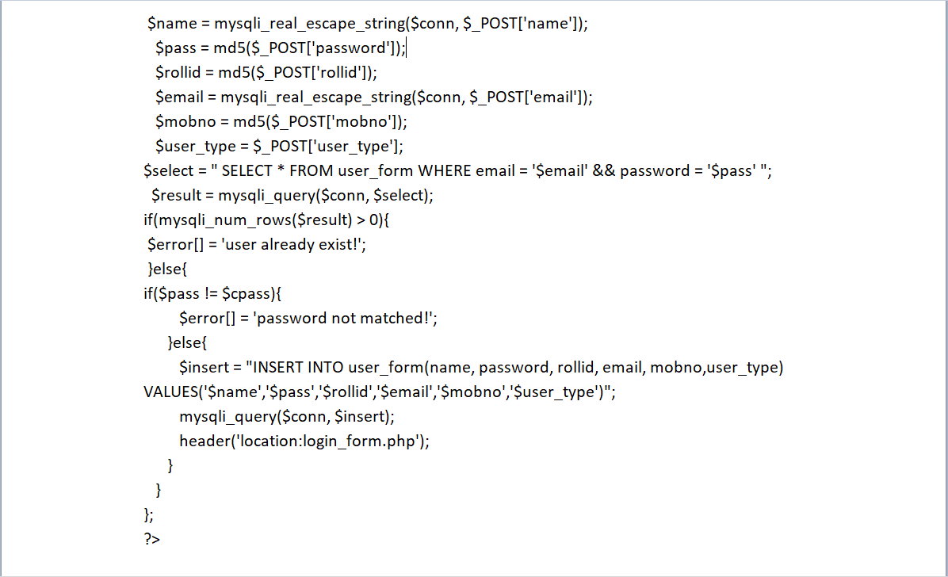

Figure 2: Code for registration page

Once, they’ve registered, they must login to access the content

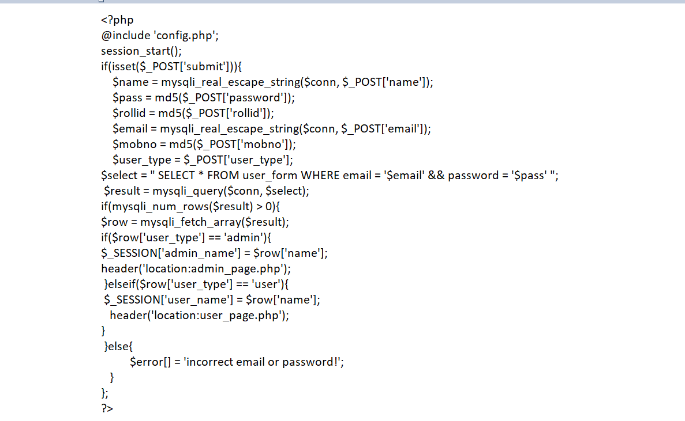

Figure 3:Code for login page

Now, they can access their content through the website

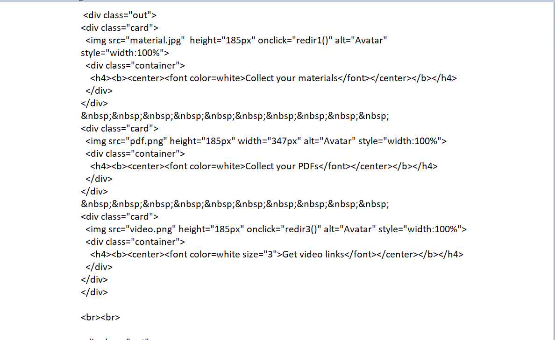

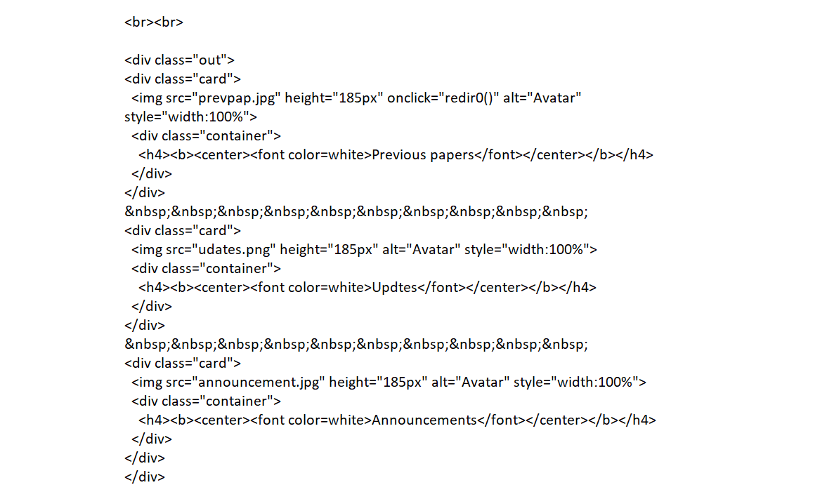

Figure 4:Code for selecting domains

**CHAPTER 3**

**SYSYEM ANALYSIS**

**3.1 EXISTING SYSTEM**

* Existing systems are mainly done for whole college.
* In existing systems, some websites contain information and updates only and the other websites contain only videos and updates, or only pdfs.
* But all the factors are together not considered for a single branch.

**3.2 PROPOSED SYSTEM**

* In proposed system, all the factors are together considered.
* All the requirements of the students related to their academics are provided at a single place.
* This is done for a single branch, that is for Computer Science and Engineering.

**CHAPTER 4**

**SYSTEM AND ARCHITECTURE**

**4.1 SYSTEM ARCHITECTURE**

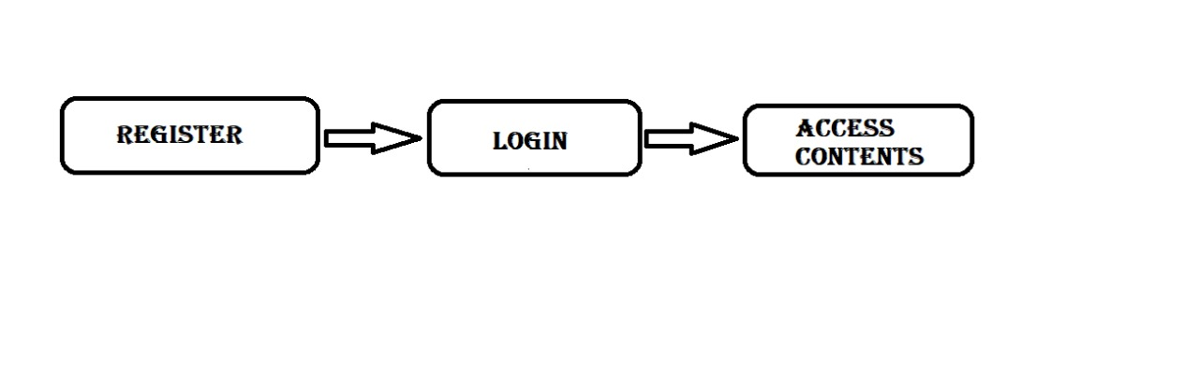

Figure 5: System Architecture

**REGISTER**

The user has to register int the website by filling certain details.

**LOGIN**

Then the user has to login to their account using the given credentials.

**ACCESS CONTENT**

Now the user can access the required content from the website.

**4.2 UML DIAGRAM**

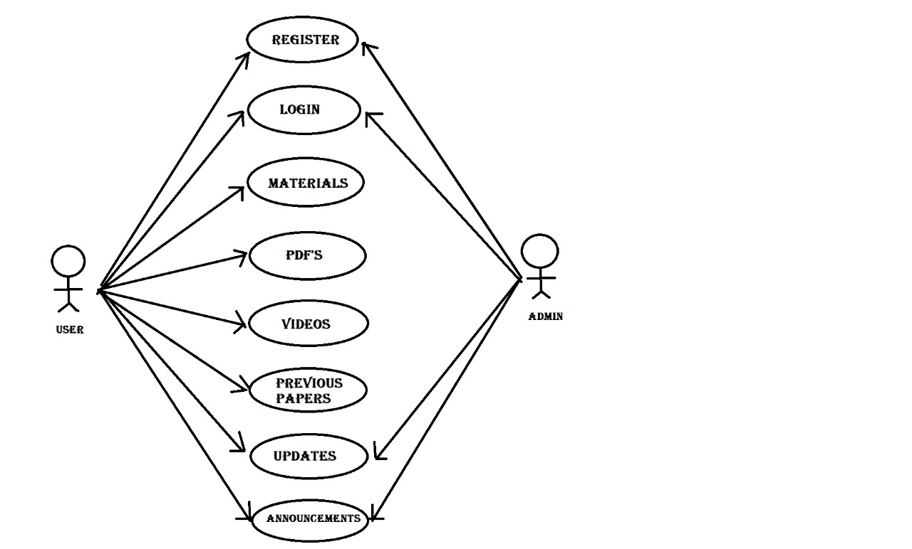

Figure 6:UML Diagram

**CHAPTER 5**

**REQUIREMENT AND SPECIFICATION**

**5.1 SYSTEM SPECIFICATIONS**

**5.1.1 HARDWARE REQUIREMENTS**

1. Processor : multi core processor (minimum dual)

2. RAM : 4GB (minimum)

3. Hard Disk : 2GB (minimum)

**5.1.2 SOFTWARE REQUIREMENTS**

1. Operating System: Windows 7,8 ,10 or 11 (32 or 64 bit)

2. Softwares needed to be : Xampp Server

Visual Studio/ Sublime Text/ Notepad

3. Scripting Languages : HTML

CSS

JS

PHP

**CHAPTER 6**

**RESULT AND DISCUSSIONS**

**6.1 Home Page**

In the home screen, there is title and certain options for the user to choose among them.

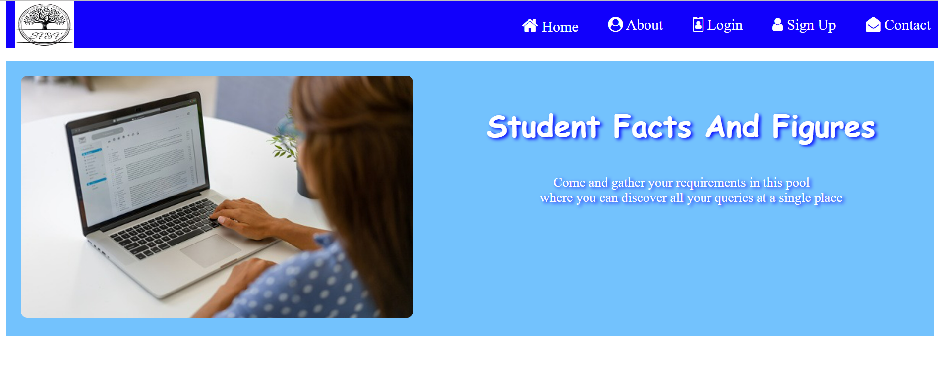

Figure 7:Home page

**6.2 Registration Model**

This page is used for registration purpose.

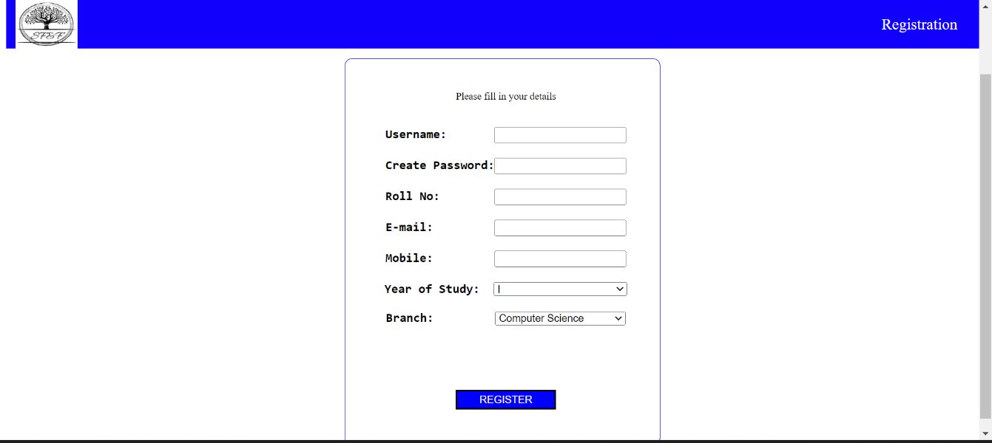

Figure 8: Registration Page

**6.3 Login Model**

This page is used for login purpose.

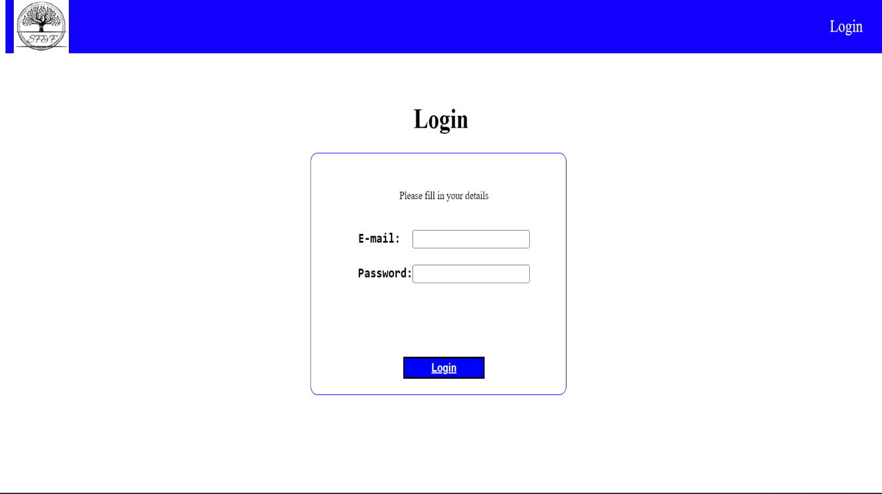

Figure 9:Login Page

**6.4 Selection Model**

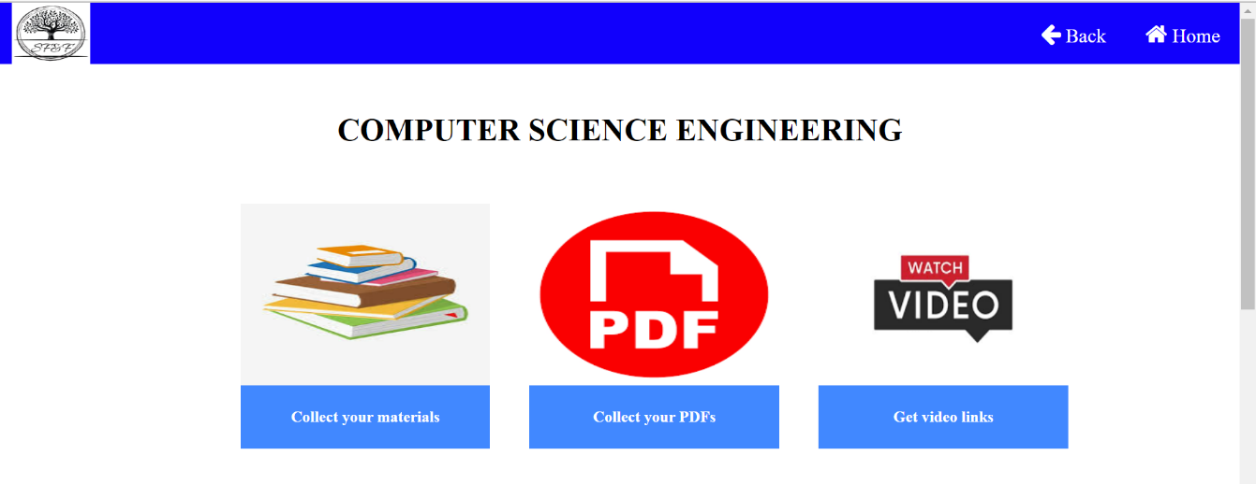

Figure 10:Selection Page Part 1

Here, the user can select the domain they wish to see.

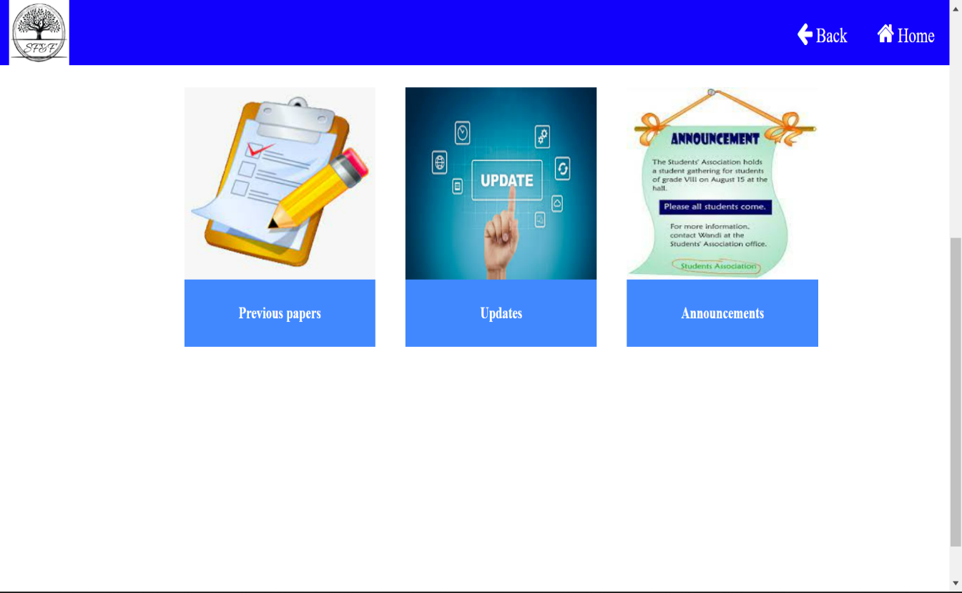

Figure 11:Selection Page Part 2

**6.5 Material / Video / PDFs Model**

Here, the user can select year-wise, semester-wise, topic-wise relevant materials.

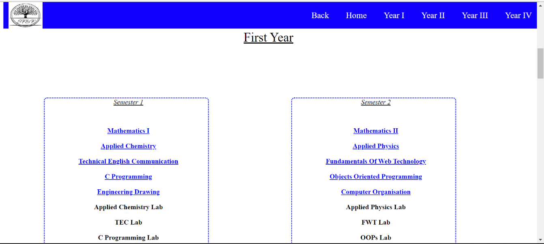

Figure 12: Material/ video/ Pdf Pages

**6.6 Previous Year’s Question Paper Model**

Here, the user can get the previous year’s question paper.

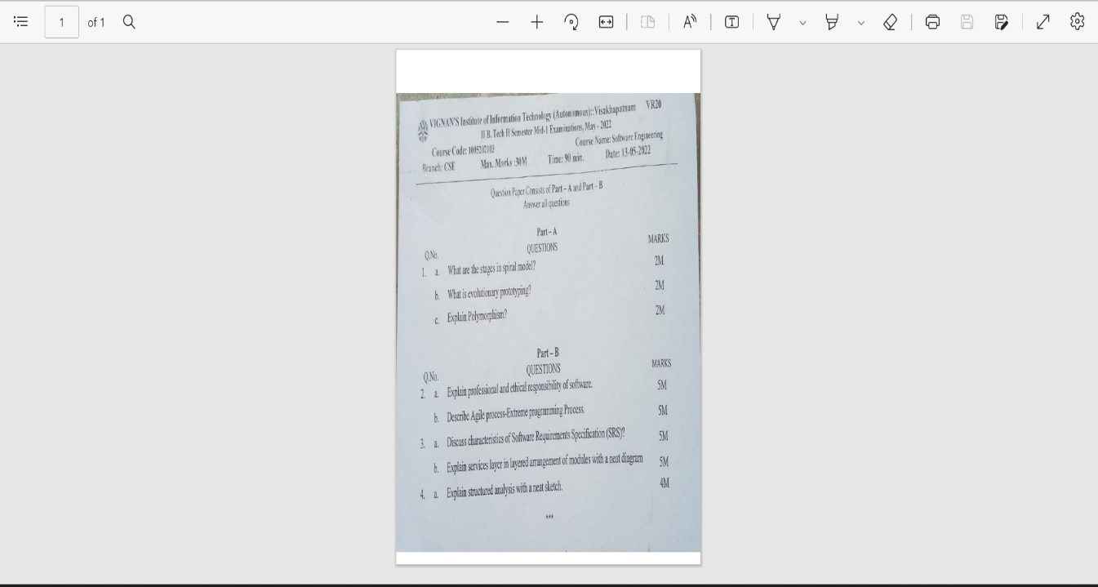

Figure 13:Previous year question papers

**6.7 Updates**

Here, user can get the updates regarding exams.

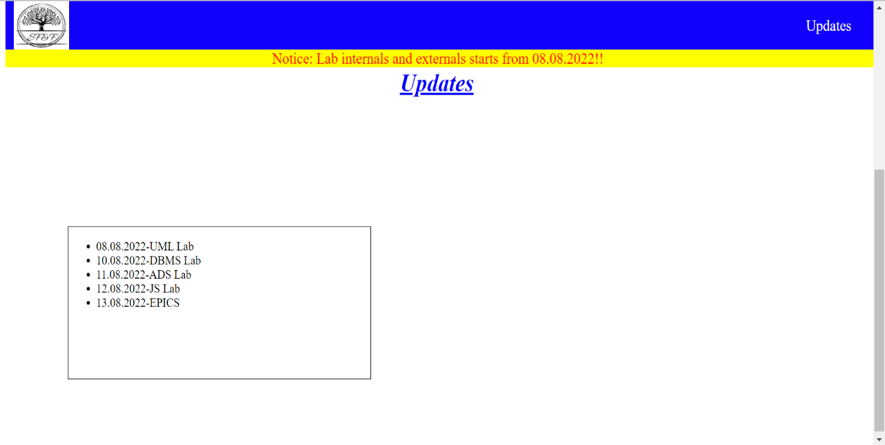

Figure 14:Updates Page

**6.7 Announcements**

Here, the user gets important announcements regarding the events that are going on in the college.

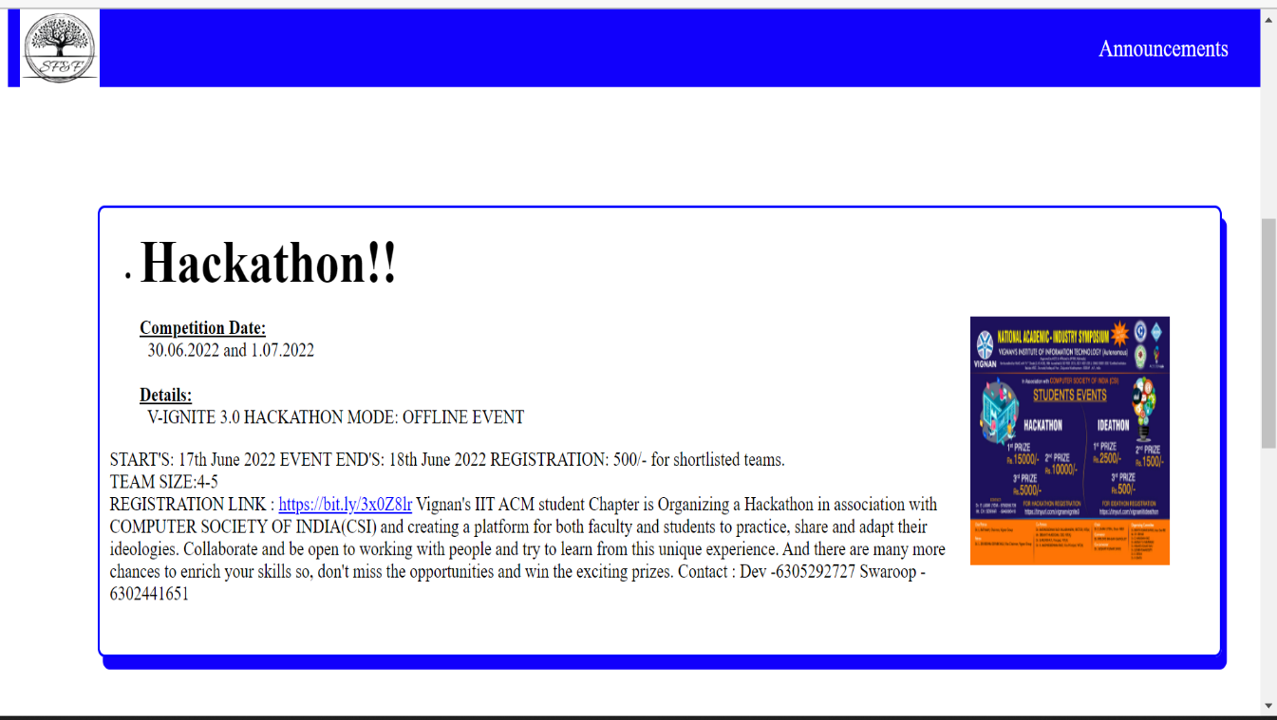

Figure 15:Announcement Page

**REFERENCES**

* [Web development - Wikipedia](https://en.wikipedia.org/wiki/Web_development)
* [The Evolution of Web Development & Its Modern Trends (decipherzone.com)](https://www.decipherzone.com/blog-detail/evolution-web-development#:~:text=Web%20Development%20was%20previously%20only,typical%20mobile%20and%20desktop%20applications.)
* [Why Website Design & Development is Important ? (systematixinfotech.com)](https://www.systematixinfotech.com/why-website-design-development-is-important-and-how-it-helps-in-making-your-business-profitable/#:~:text=A%20well%2Ddesigned%20website%20is,promote%20a%20company's%20brand%20name.)
* [How to Design a Website: 7 Key Principles for visually appealing websites | The Jotform Blog](https://www.jotform.com/blog/how-to-make-a-web-design-look-good/)
* [Web development methodologies and approaches | ADCI Solutions](https://www.adcisolutions.com/knowledge/web-development-methodologies-and-approaches)
* [10 Web Development Frameworks You Must Know About in 2022 (citrusbug.com)](https://citrusbug.com/blog/best-web-development-framework)
* [The 9 Most Popular Types of Websites and What They Include (99designs.com)](https://99designs.com/blog/web-digital/types-of-websites/)
* [Web Development Life Cycle: A New Methodology for Web Development (signitysolutions.com)](https://www.signitysolutions.com/blog/web-development-life-cycle/#:~:text=Web%20development%20is%20a%20constant,development%2C%20testing%2C%20and%20maintenance.)
* [8 Best Front End Programming Languages | Simplilearn](https://www.simplilearn.com/tutorials/programming-tutorial/best-front-end-programming-languages)
* [Top 8 Back-End Coding Languages for Web Development | Indeed.com](https://www.indeed.com/career-advice/career-development/backend-languages)